**Supplementary 4: The alternative embedding methods tested**

List:

* Figure 1: Classical multidimensional scaling (classical MDS)
* Figure 2: Principal Component Analysis (PCA)
* Figure 3: *t*-distributed Stochastic Neighbor Embedding (t-SNE), perplexity 30
* Figure 4: *t*-SNE, perplexity 50
* Figure 5: *t*-SNE, perplexity 100
* Figure 6: *t*-SNE, perplexity 190
* Figure 7: Uniform Manifold Approximation and Projection (UMAP), n_neighbours 15
* Figure 8: UMAP, n_neighbours 100
* Figure 9: UMAP, minimum distance 0.1
* Figure 10: UMAP, minimum distance 0.3
* Figure 11: UMAP, minimum distance 0.5

Data matrices used for plotting were generated in script ‘Four_LPPMultiverse_DimensionReductionForActiveLearning.m’, and plots were created in script ‘Five_LPPMultiverse_VisualiseDimensionReduction.m’.

**All figures show the distribution of all 528 pipelines with respect to pairwise Euclidean distances in the LPP difference scores across the condition vector, in the two-dimensional space after embedding using the method in the plot title. *N* = 20 participants (the training sample taken from the full sample of 98 participants).**

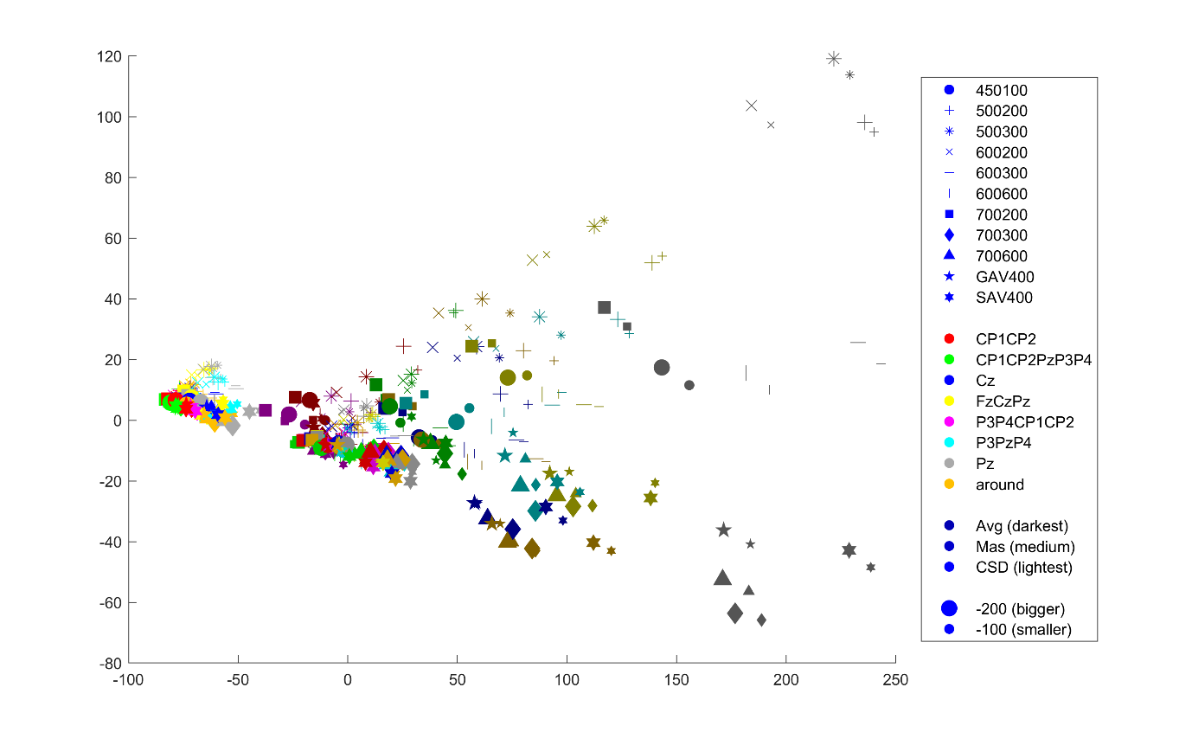Figure 1: Classical MDS:

Figure 2: PCA



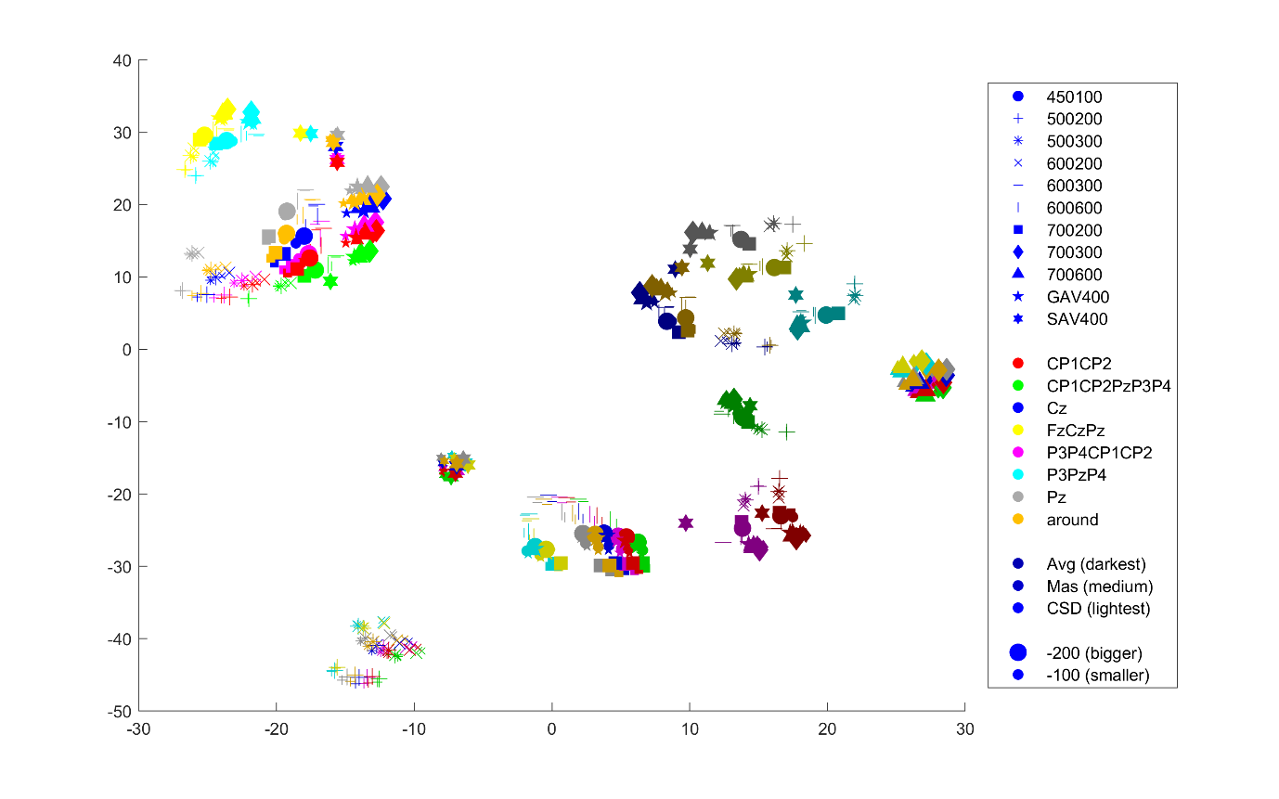Figure 3: *t*-SNE, perplexity 30

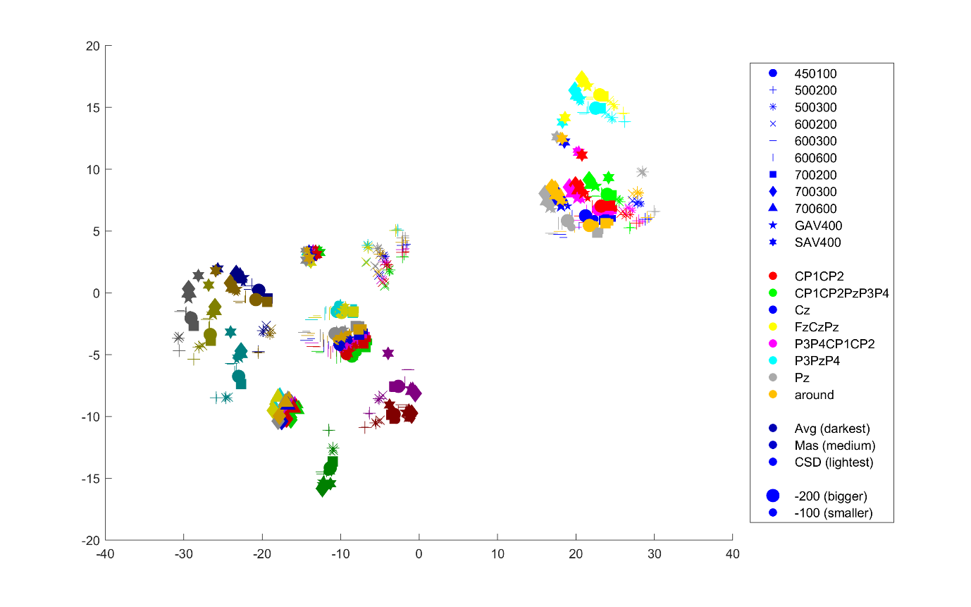Figure 4: *t*-SNE, perplexity 50

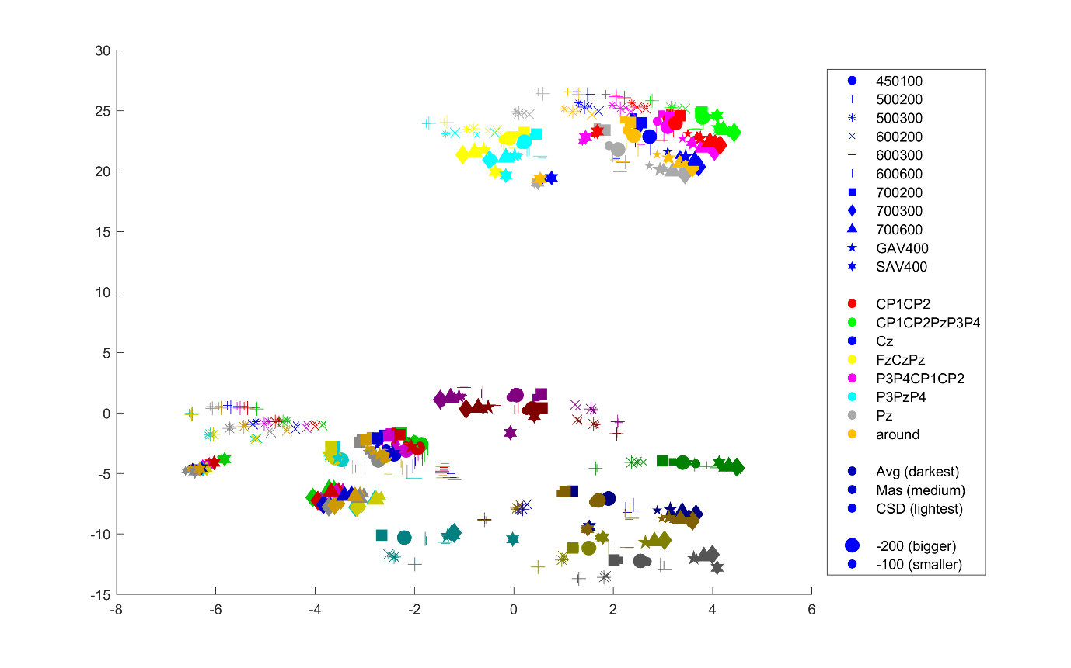Figure 5: *t*-SNE, perplexity 100

Figure 6: *t*-SNE, perplexity 190

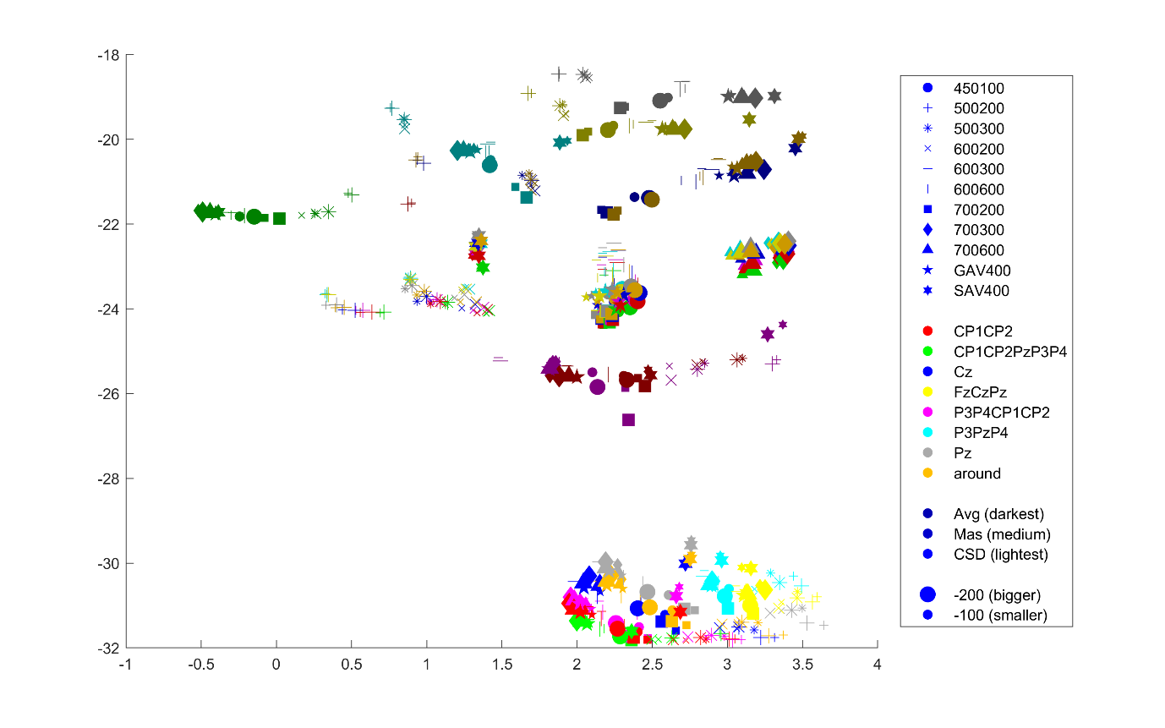

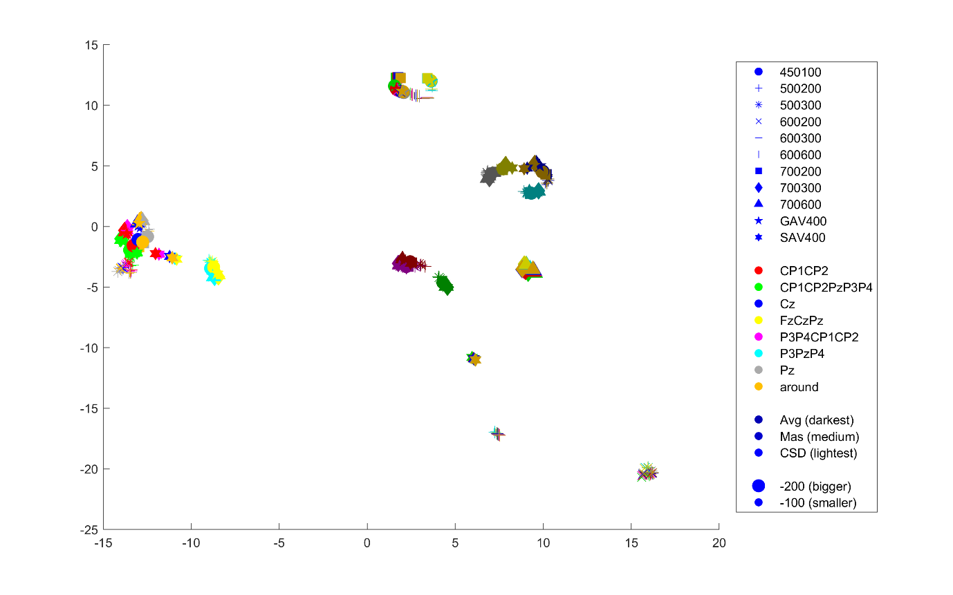Figure 7: UMAP, n_neighbours 15

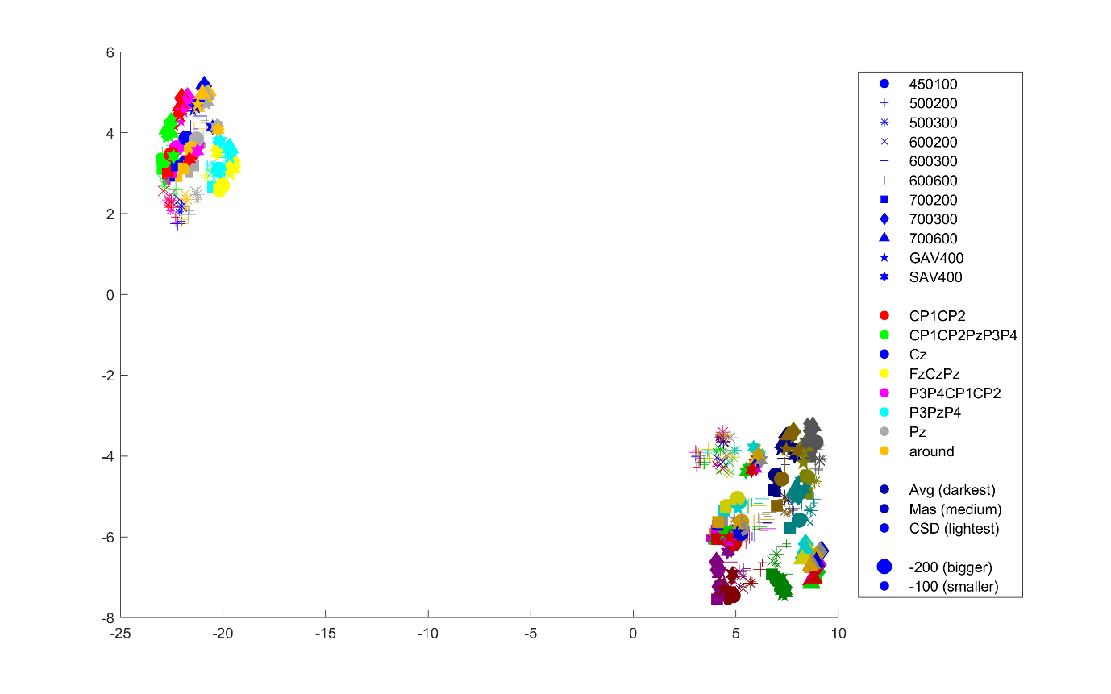Figure 8: UMAP, n_neighbours 100

Figure 9: UMAP, minimum distance 0.1



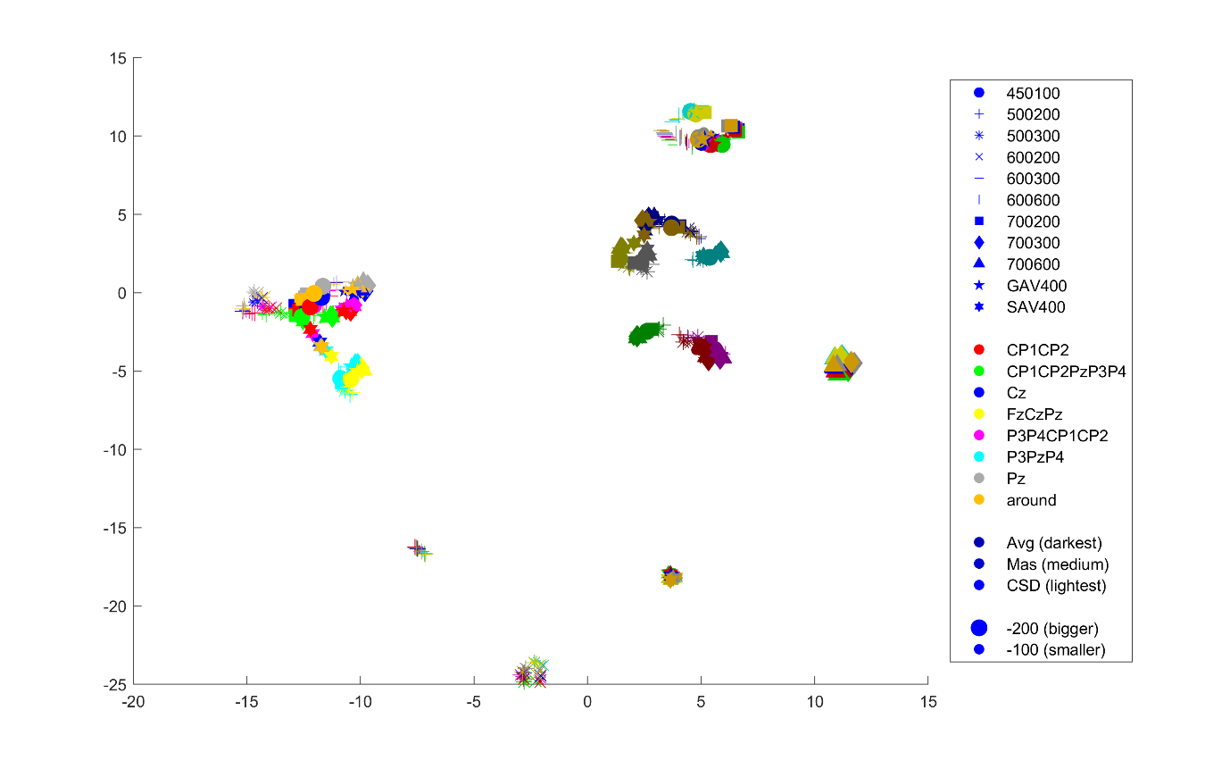Figure 10: UMAP, minimum distance 0.3

Figure 11: UMAP, minimum distance 0.5

